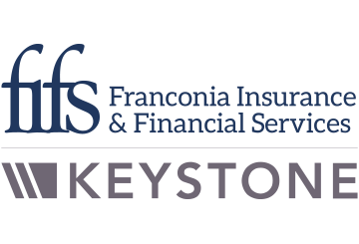
Amazon Launches Subscription-based Prescription Drug Service
Provided by: Franconia Insurance & Financial Services
On Jan. 24, Amazon announced a new Prime membership benefit from Amazon Pharmacy. RxPass will be available only as a subscription service for customers who have Amazon Prime memberships. For $5 a month, people can fill as many prescriptions as they need from a list of roughly 50 generic medications. The fee would be out of pocket and in addition to an Amazon Prime membership fee.
Amazon noted that Prime members could get discounts of up to 80% off generic drugs and 40% off brand-name medications at more than 60,000 pharmacies across the country. Medications that treat more than 80 common conditions—such as high blood pressure, anxiety and acid reflux—are included in the subscription. Click here for a complete list of RxPass medications.

“Any customer who pays more than $10 a month for their eligible medications will see their prescription costs drop by 50% or more, plus they save time by skipping a trip to the pharmacy.”
- John Love, vice president of Amazon Pharmacy

RxPass is available in most states but has yet to send medications to California, Louisiana, Maryland, Minnesota, New Hampshire, Pennsylvania, Texas and Washington. Additionally, people with government-funded Medicaid or Medicare coverage aren’t eligible. Amazon accepts most health insurance plans except for use with RxPass. It also said customers may use their health savings or flexible spending accounts when not paying through RxPass.
What Does It Mean?
Health care costs in the United States have risen sharply over the past two decades, and prescription drug affordability is a major factor in that growth. According to the Kaiser Family Foundation, 62% of adults take at least one prescription drug, and 25% say they take four or more medications. Also, 32% of adults say they have difficulty affording their prescriptions. Unsurprisingly, the more prescriptions a person has, the harder it becomes to afford them. Not getting medications filled can result in poor health outcomes for many Americans.
Amazon’s launch of RxPass is an effort to help make medications more accessible and affordable in the United States. This service is another example of Amazon’s continued expansion into the health care market.
Employers should continue to monitor health care trends, utilization and spending. Contact Franconia Insurance & Financial Services for more health care-related resources.

